## How The Web Works

### *The Structure of WWW

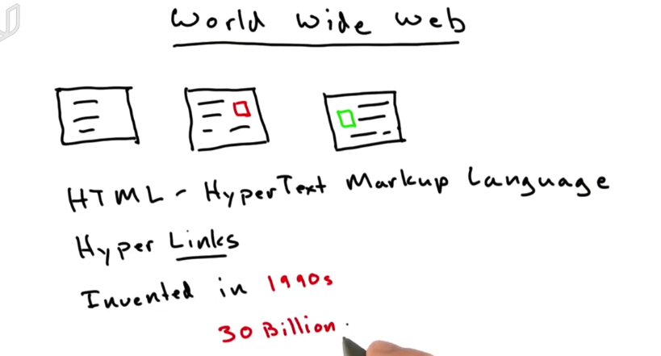

WWW is a collection of HTML documents. Almost every webpage is based on HTML.

HTML links to each other by hyper-links, which makes the network like a web.

All other types of document like picture, video, radio, etc can exist on the web. But HTML is the main content in the web.

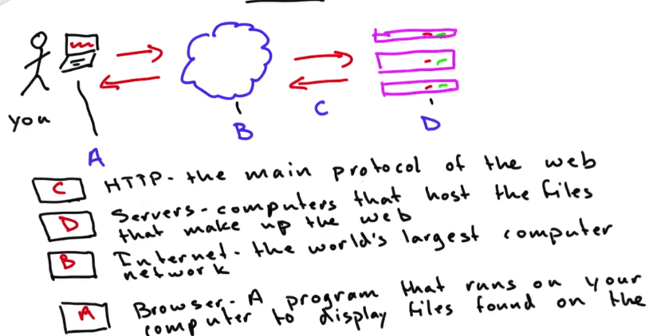

Your computer makes request via internet to service. These requests are using a protocol called HTTP. The server responds with files that your browser displays.

Servers are just like your computer. They sit in a closet and host the files.

### What Is HTML?

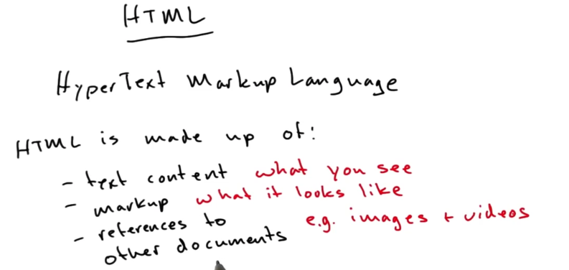

HTML is made up of content, markup and other resources.

Content and markup is separated which means you can develop them separatedly.

### HTML Elements

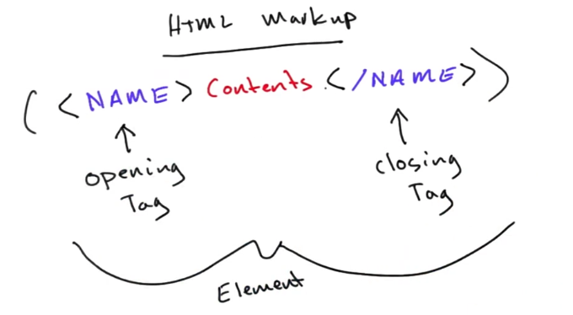

<b></b>

<em></em>

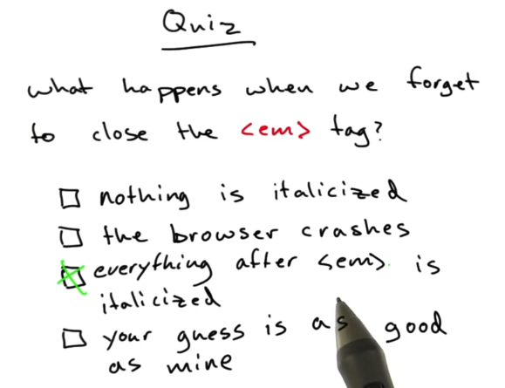

#### <a>

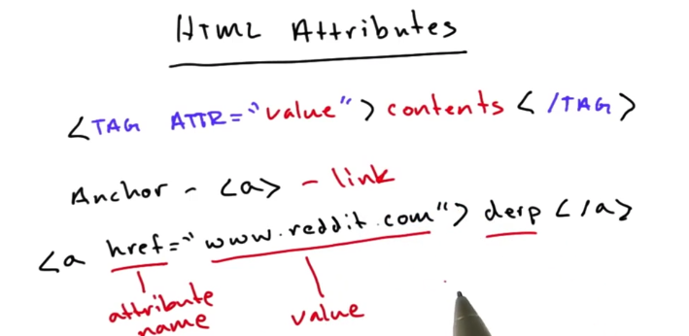

a for anchor, which is to make links.

These are still tags. But inside the opening tag, you can add some attribute=”value” pairs to it.

#### <img>

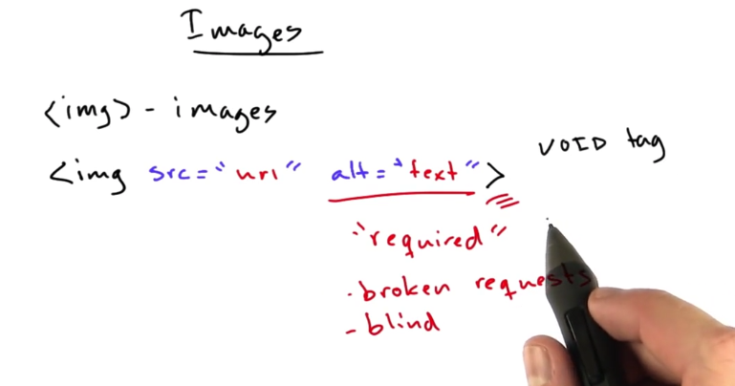

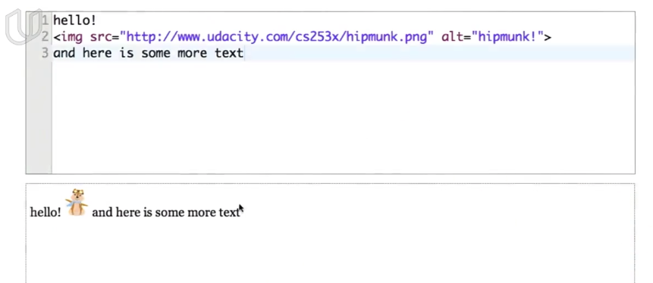

<img src = “url to download the image” alt=”if not download successfully, the alternative content will show”>

No content for image tag. No closing tag.

#### <br>

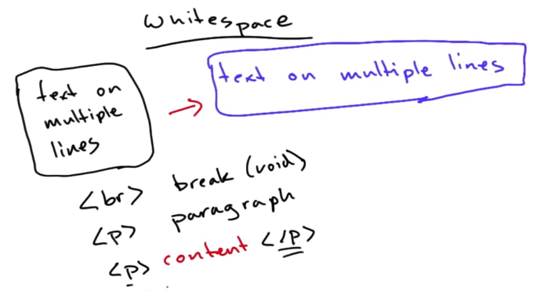

To turn to a new line, you can use <br> tag or <p> tag

#### <p>

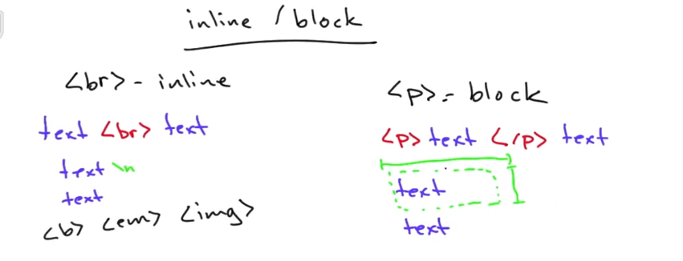

Inline element, just text.

Block element actually makes a invisible box, which has height, width, color, etc.

#### <span> & <div>

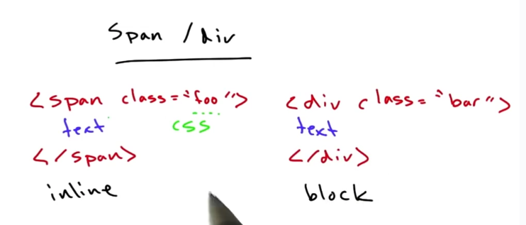

Span and div are just container of text. They can control how text is laid out.

You can attach style to them by declaring class attribute

#### Structure of HTML Document

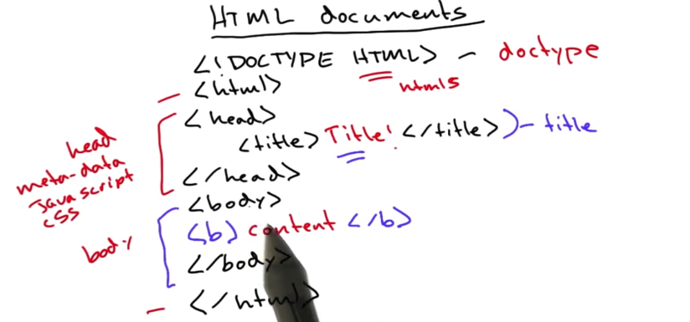

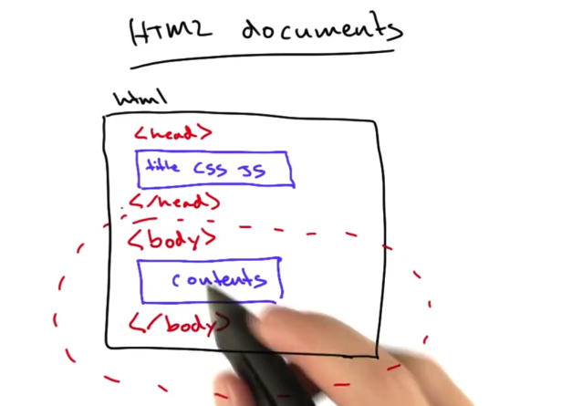

### *URL

#### Protocol & Host & Path

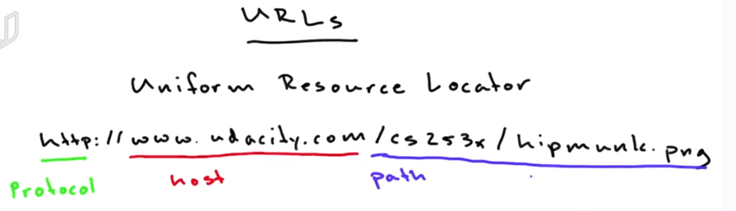

Host: This is the host name or domain name of the server which has the document that we want to access. The host can also be an IP address. The host will translate the host name into an IP address. The path specifies where to fetch the document inside the server.]

#### *Query Parameters

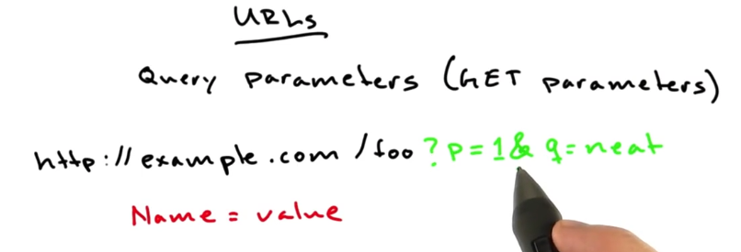

Query parameters in URL: question mark in the head and & to connect multiple query parameters.

#### Fragment

Fragments is to reference the particular part of the page you’re looking at. It will not be sent to the server. It just be kept in browser.

#### Port

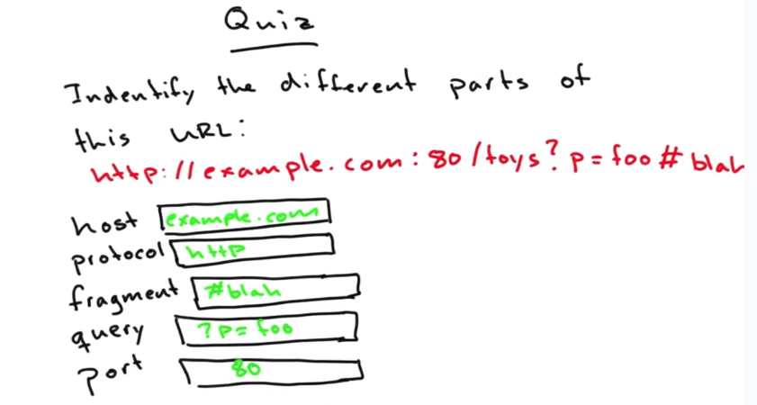

### HTTP

#### HTTP Request

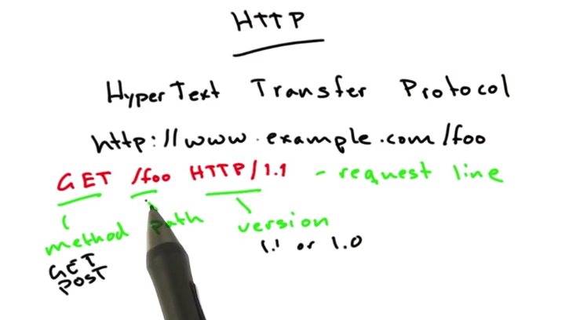

Http is the main protocol of the web. HTTP is what the browser used to talk to the web server.

Host name is used to make connect. The path is used to make request.

Your browser will send some kind of request line to the server.

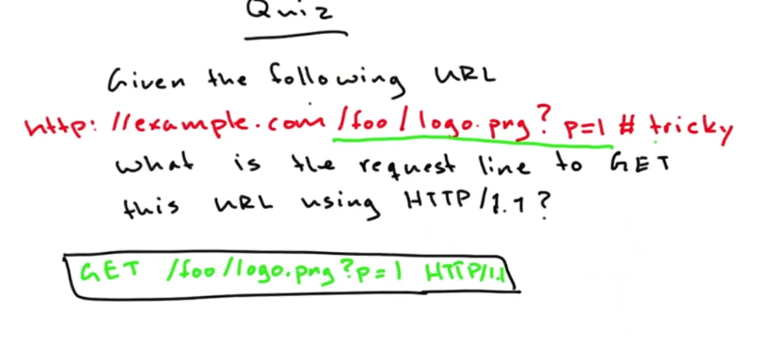

The fragment stays in the client side.

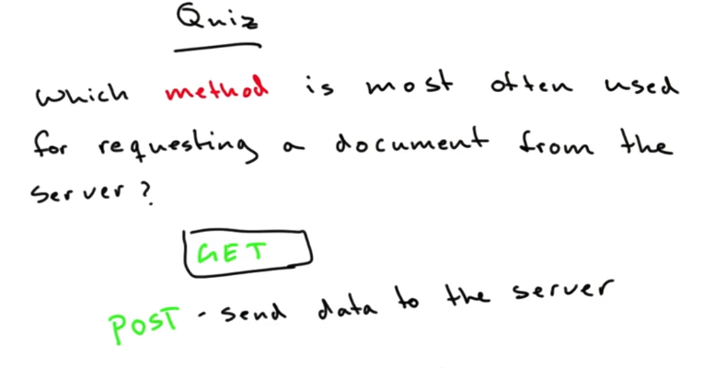

GET is to request documents from the server.

POST is to send data to the server.

#### *HTTP Request Headers

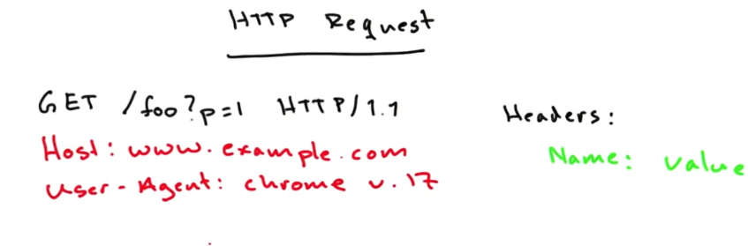

The request line is followed by the headers, which has Name:Value format.

One name is the host. Although your browser already connect to the server, but the same server may contain multiple website. The head specifies which website you are requesting.

User-agent tells who is making the request.

Value can be anything you want. But an honest user-agent head will help to maintain good web environment for everyone.

#### *HTTP Responses

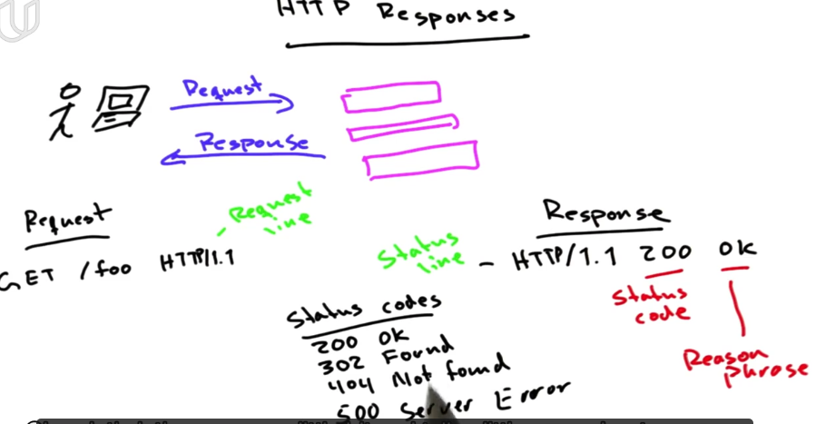

HTTP response: status codes start with 4 digits:

2: success 3: potentially success but need some adjustment

4: error on client side 5:error on server side.

### Servers

#### Web Application

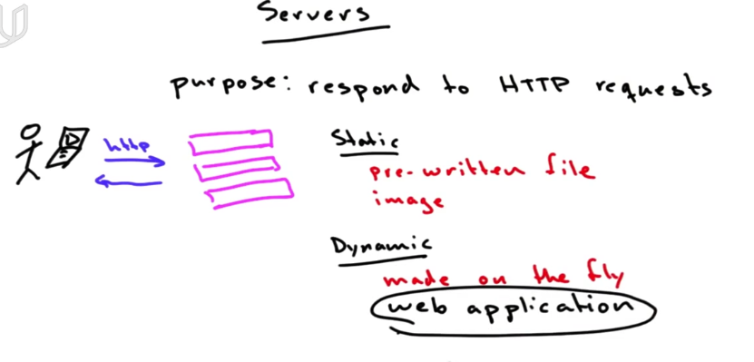

The kinds of request made to the server: static or dynamic.

Dynamic request: the response is built on the fly by a program that’s running, called web application.

Web applications execute in web server, speak http and generate content that your browser request.

## Forms and Input

<form action = “www.google.com/search”>

<input name = ”q”>

<input type = “submit”>

</form>

When you press submit, suppose you enter “udacity” in input form. Then the url will change to original url attached with ?q=udacity.

In form, if you add attribute action =”www.google.com/search”. Then after press submit button, the url becoms [www.google.com/search?q=udacity](http://www.google.com/search?q=udacity)

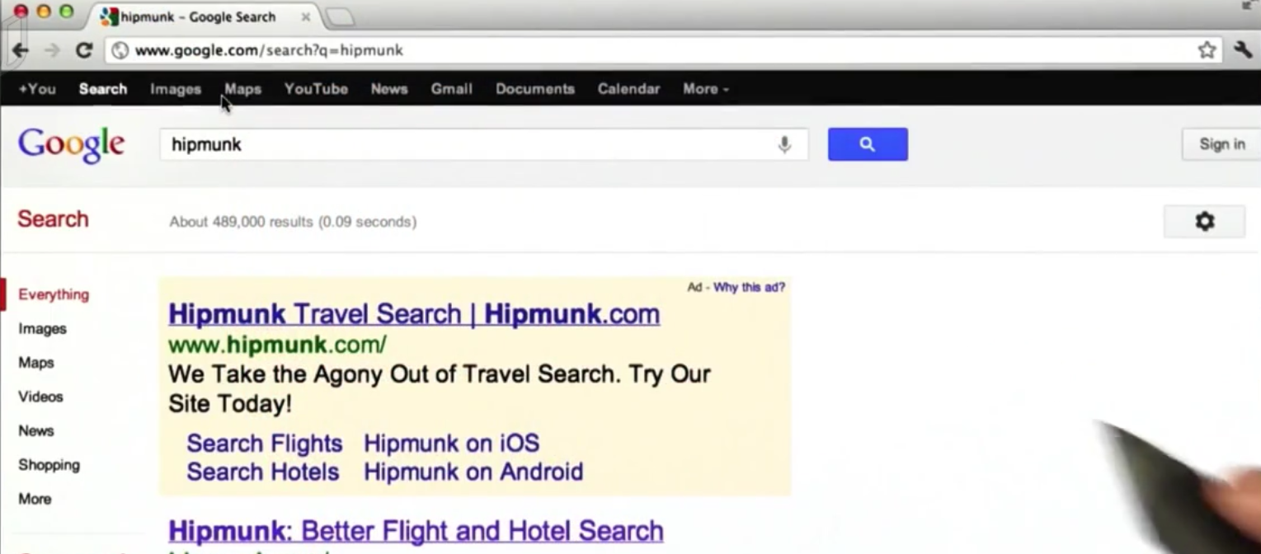

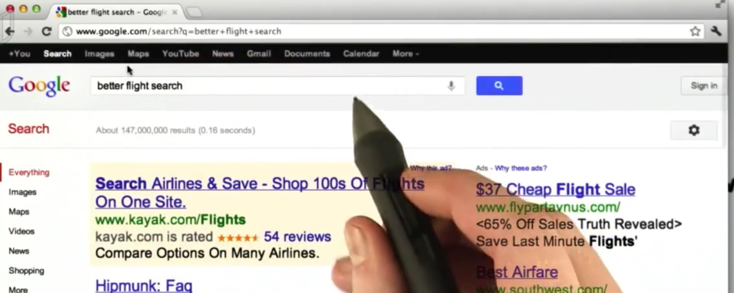

If you type several words with blanks, the result will be q=word1+word2+…

## *Ping

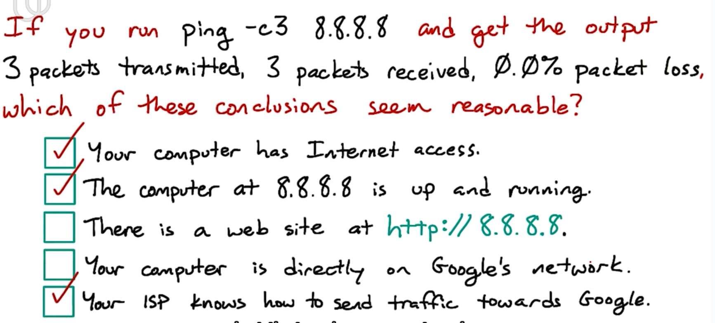

ping -c3 8.8.8.8

8.8.8.8 is an address of particular service on the Google.

**Ping is a command for testing whether your computer can send and receive network traffic with that address. Ping is also a kind of protocol.**

-c3 means to send 3 test messages.

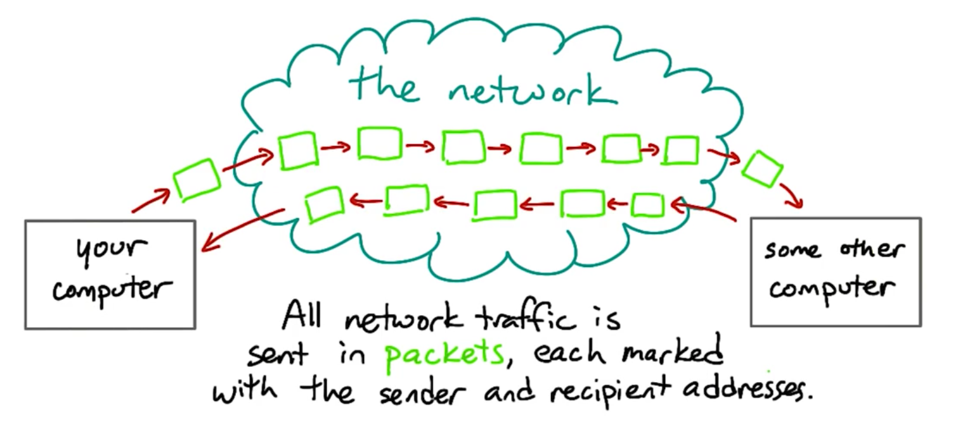

All traffic on the Internet is split into messages called packets

A packet is a short message that send from one computer to anther with the sender’s address and receiver’s address.

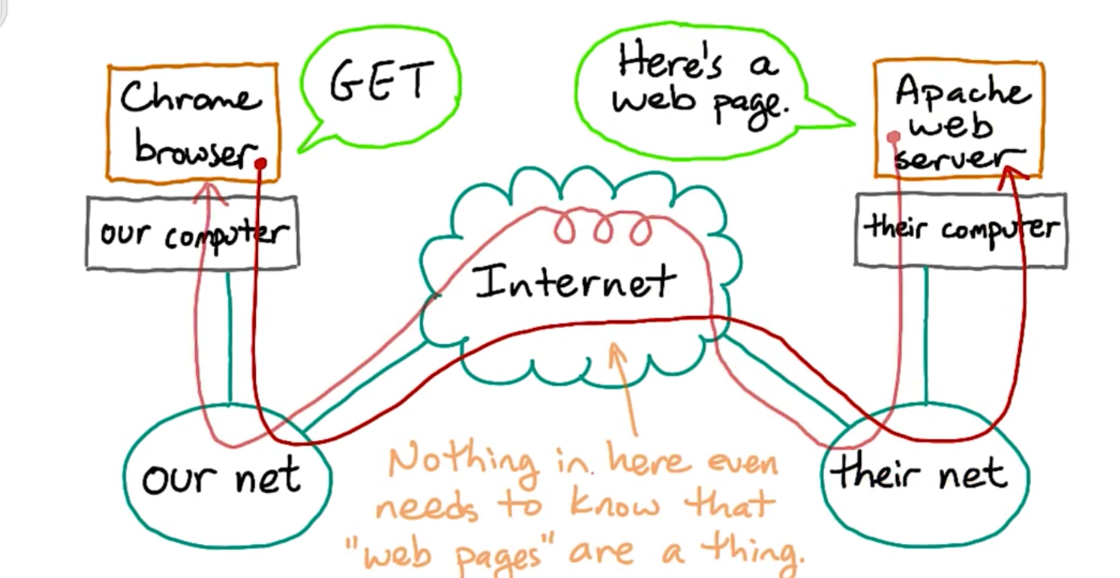

If you make a HTTP request and try to get a html page from the web server.

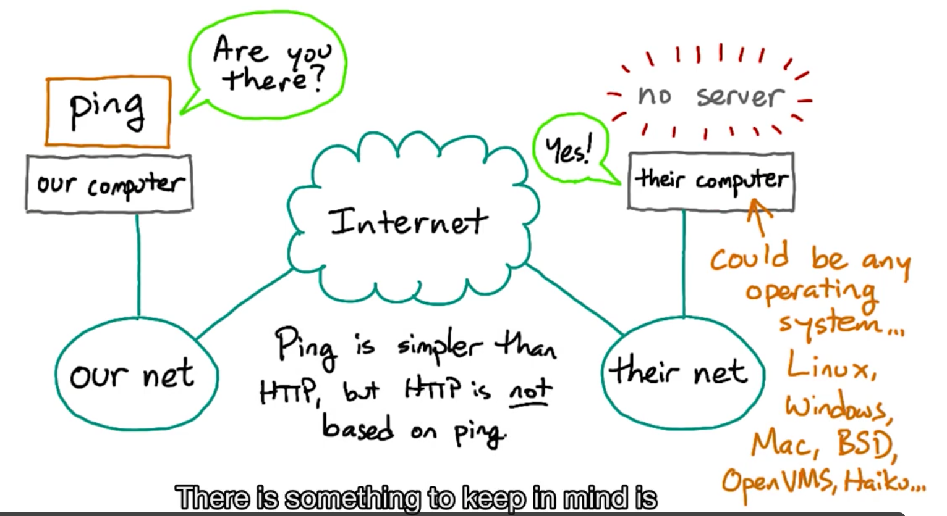

The ping request will goes to the operating system of the receiver. There is no ping server.

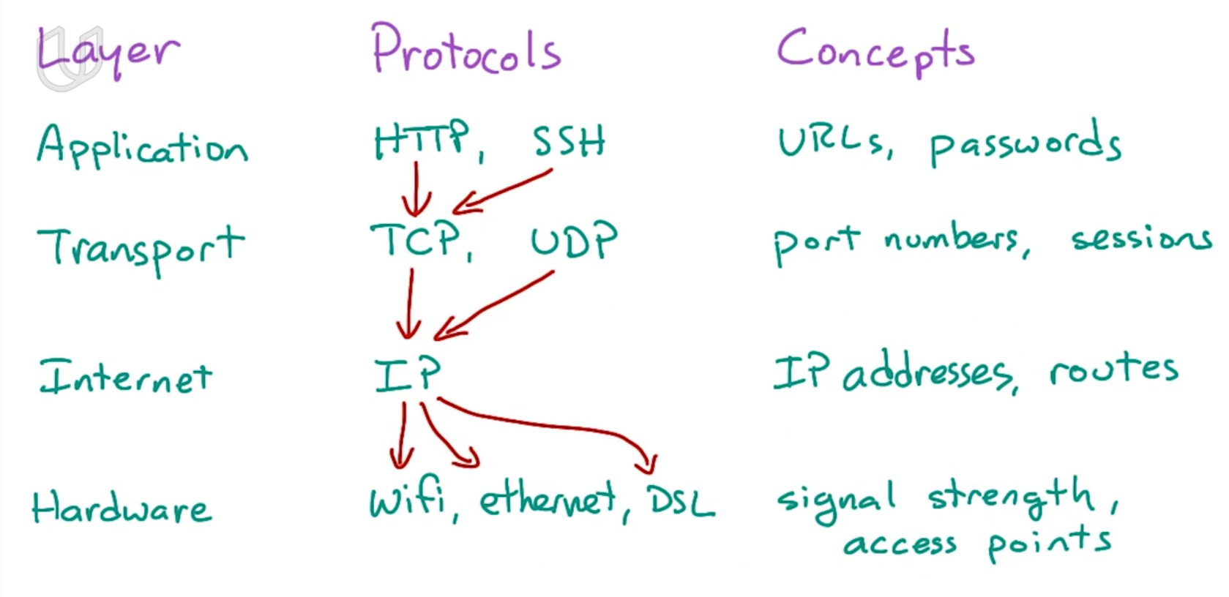

## *IP Address and DNS

IP address is used to designate a particular destination on the internet.

Everything transmitted on the internet is split into packets. And every packet has the IP address of where it comes from and where it goes.

Host: host is a machine that might host services.

When you ping an host name, you will get ip address. The ip address could be different because Google wants to balance the overhead among their data centers.

How is a host name translated into ip address? DNS

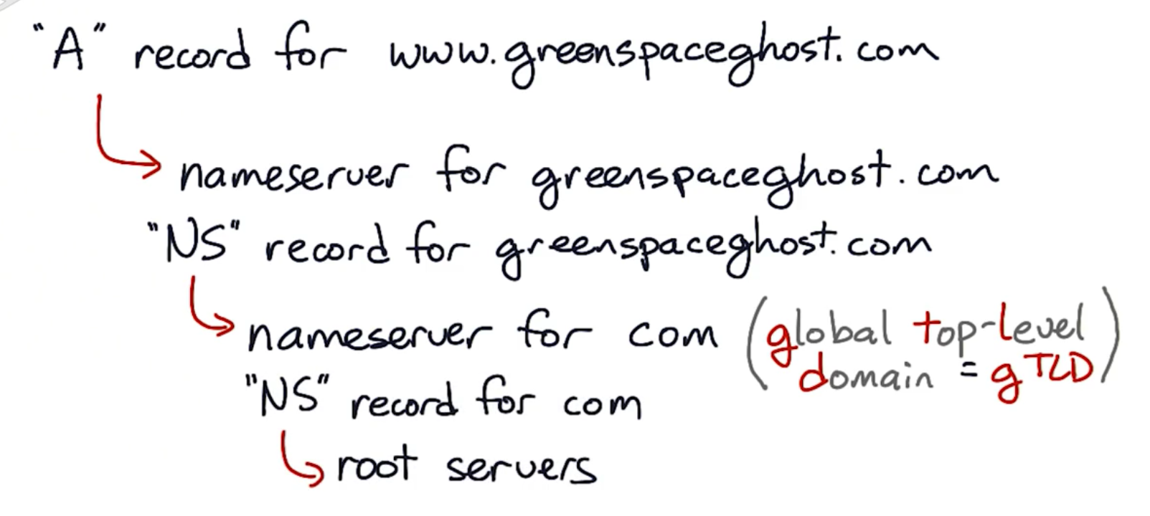

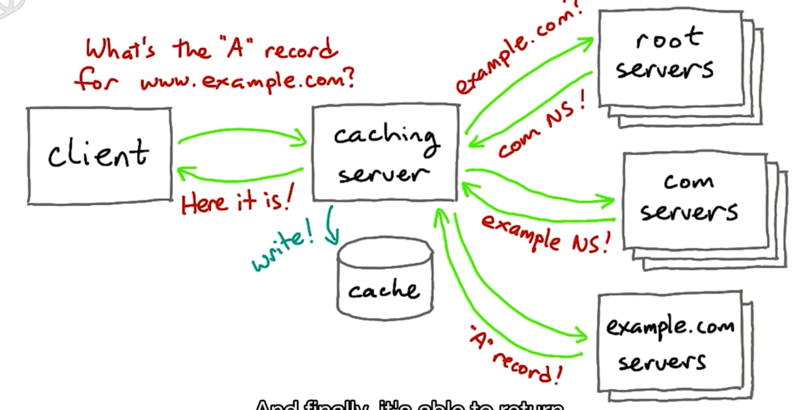

When client wants to get the ip address for a URL, first search in cache. If not exist here, use DNS to search for the ip address.

DNS is divided into several levels. The gloval top-level domain is like com org edu. DNS will search each level from the top one to the bottom until the address is found.

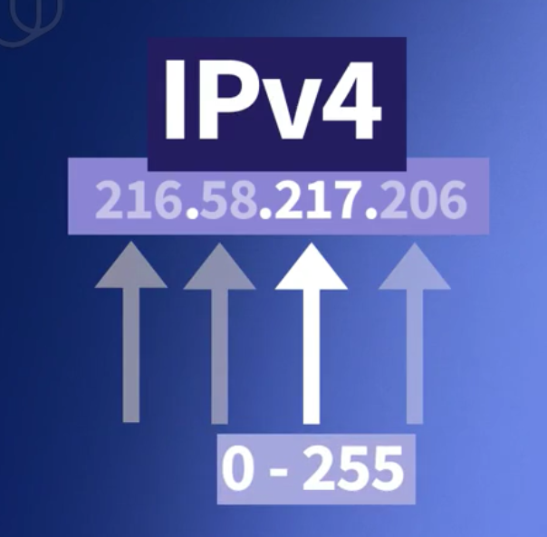

Ipv4: 4 numbers, each number is 8 bits.

## *Netblock and Router

Computers on the same network usually have the similar ip address.

All the addresses on the same netblock share the common prefix. They can communicate with each other without router.

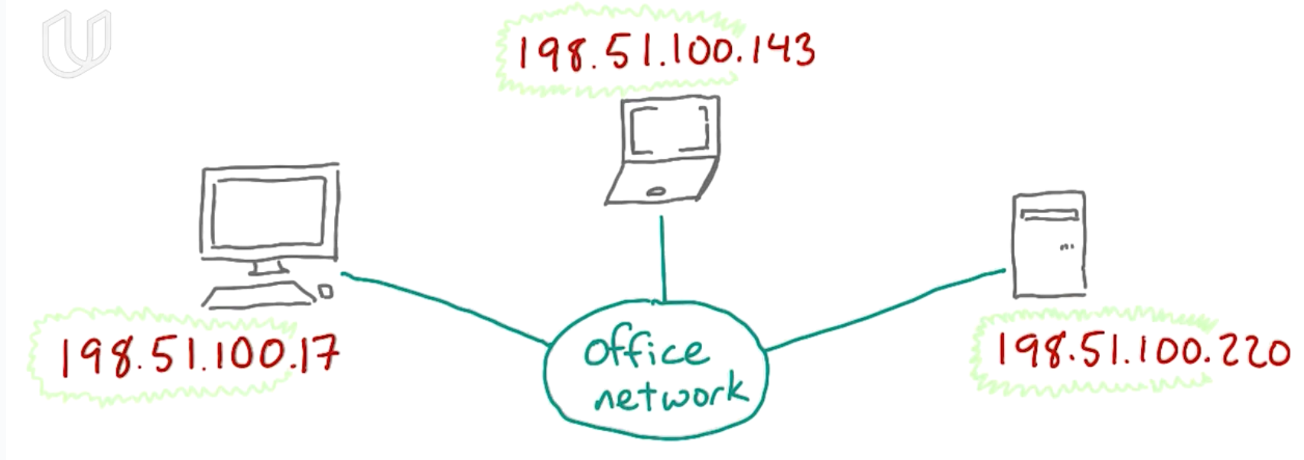

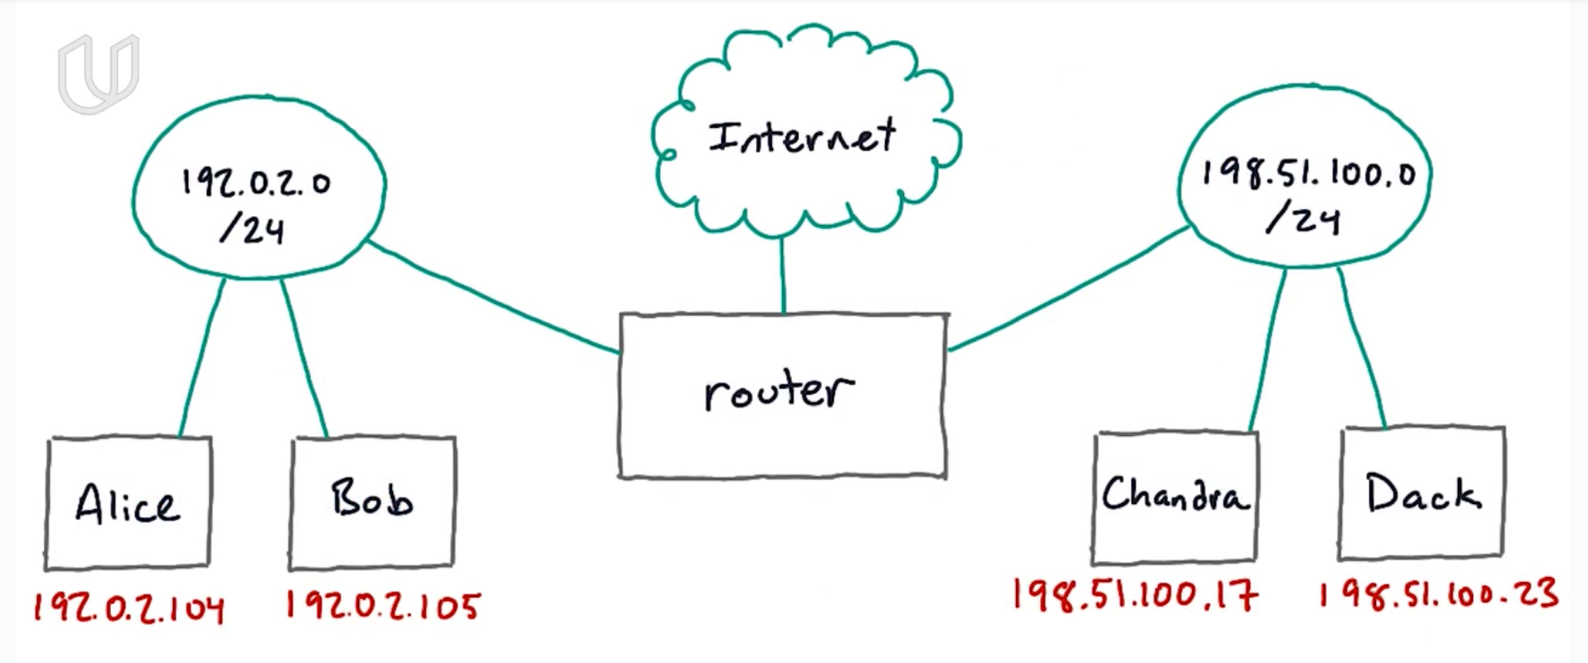

A router is a device that connects two different IP **netblocks**. It acts like gateway.

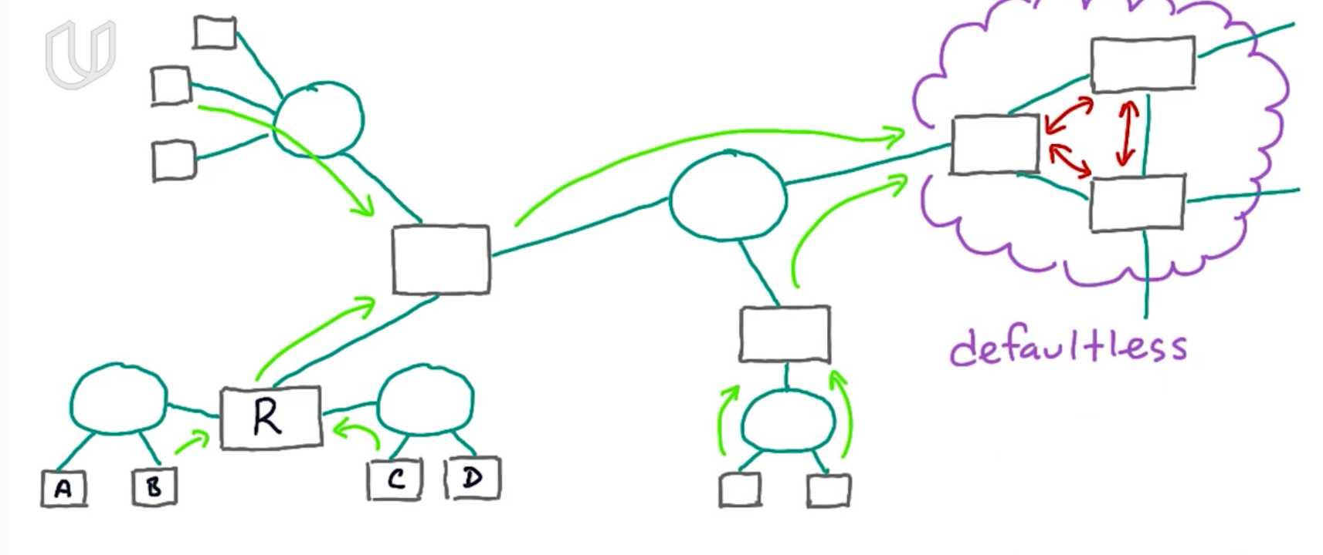

## *Protocol Layer

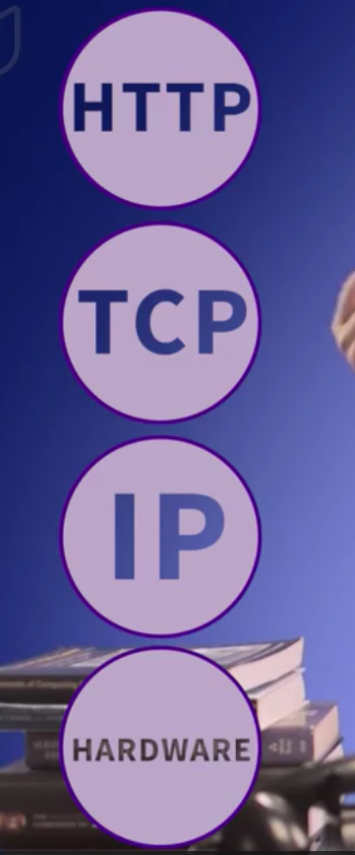

Each layer depends on the layer below and will hide the implementation details to simplify.

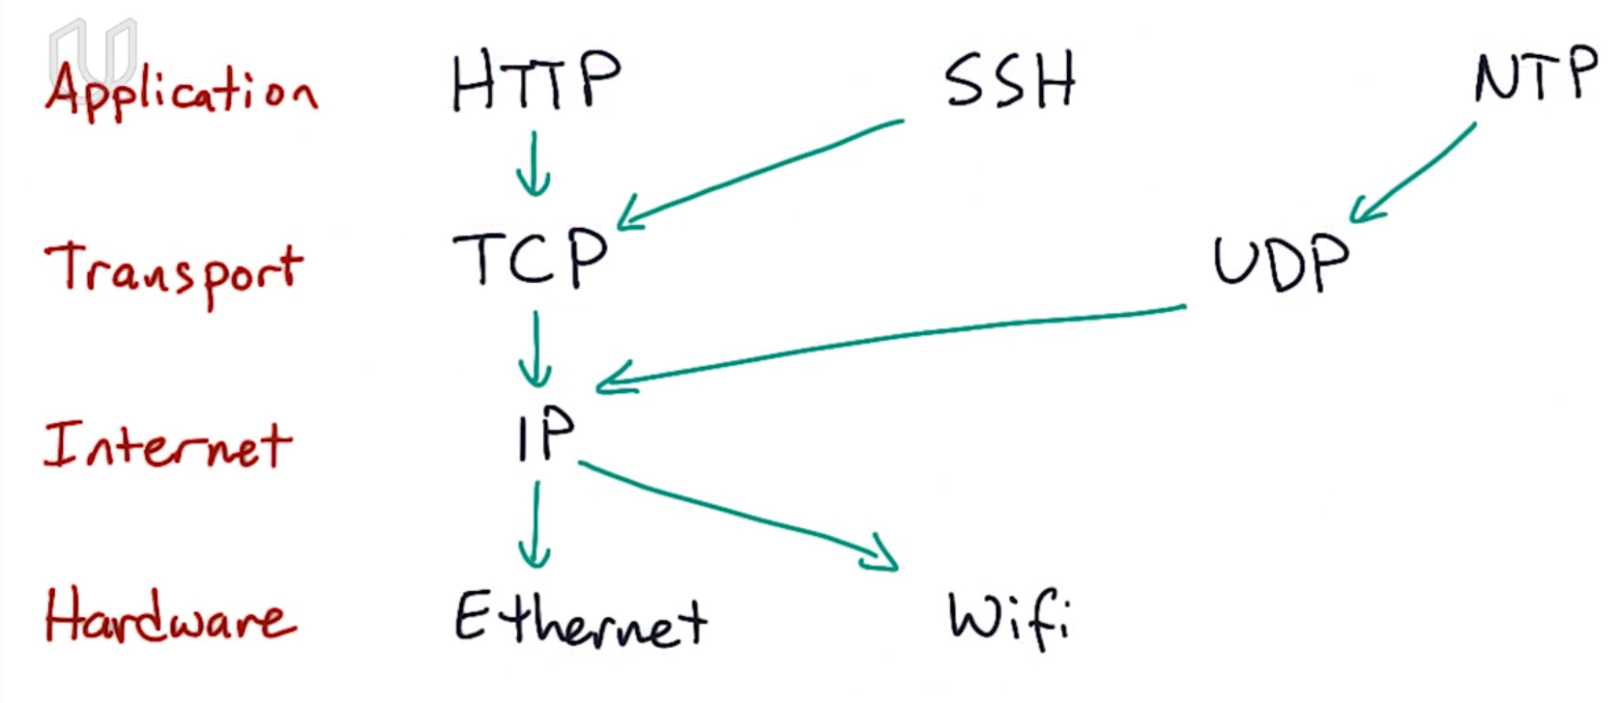

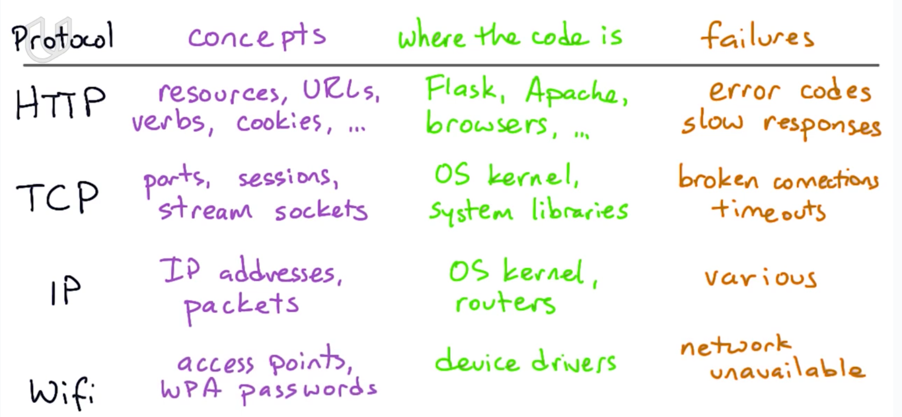

HTTP, TCP, IP are three protocols in application, transportation and internet layers.

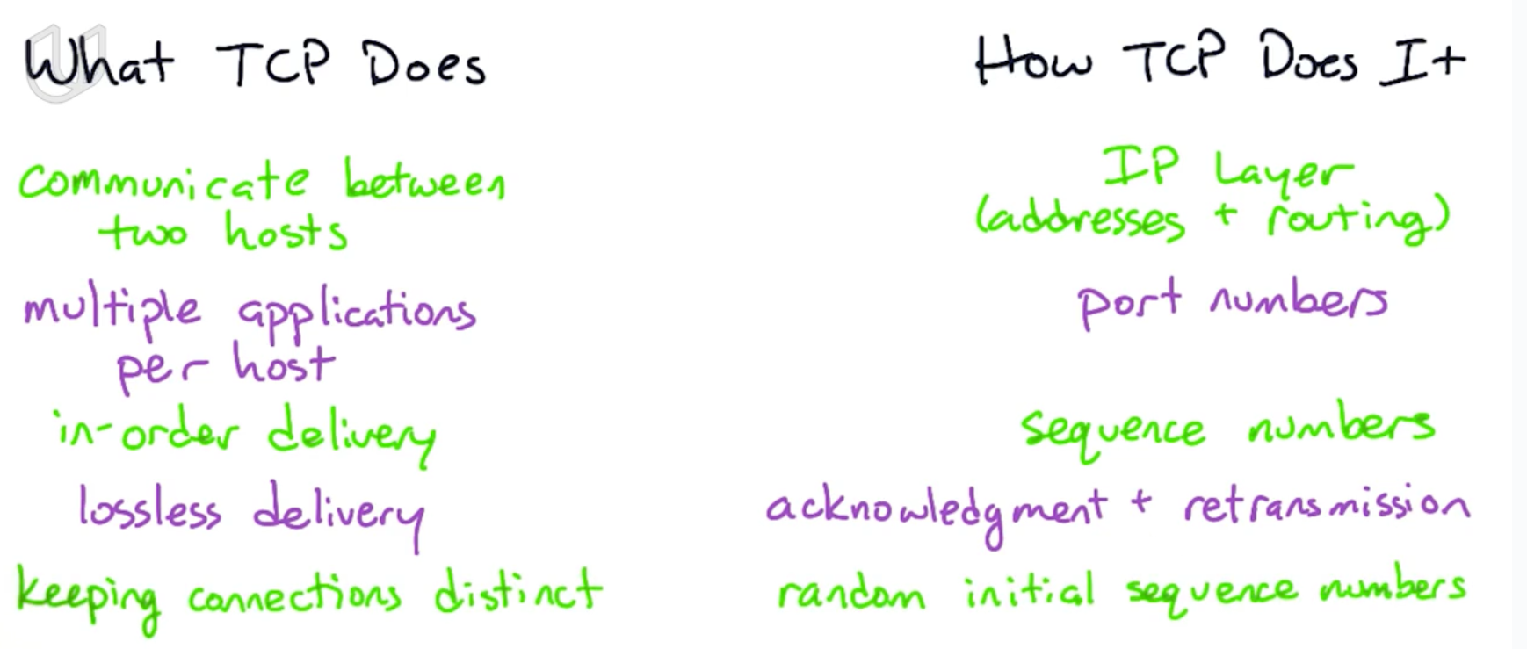

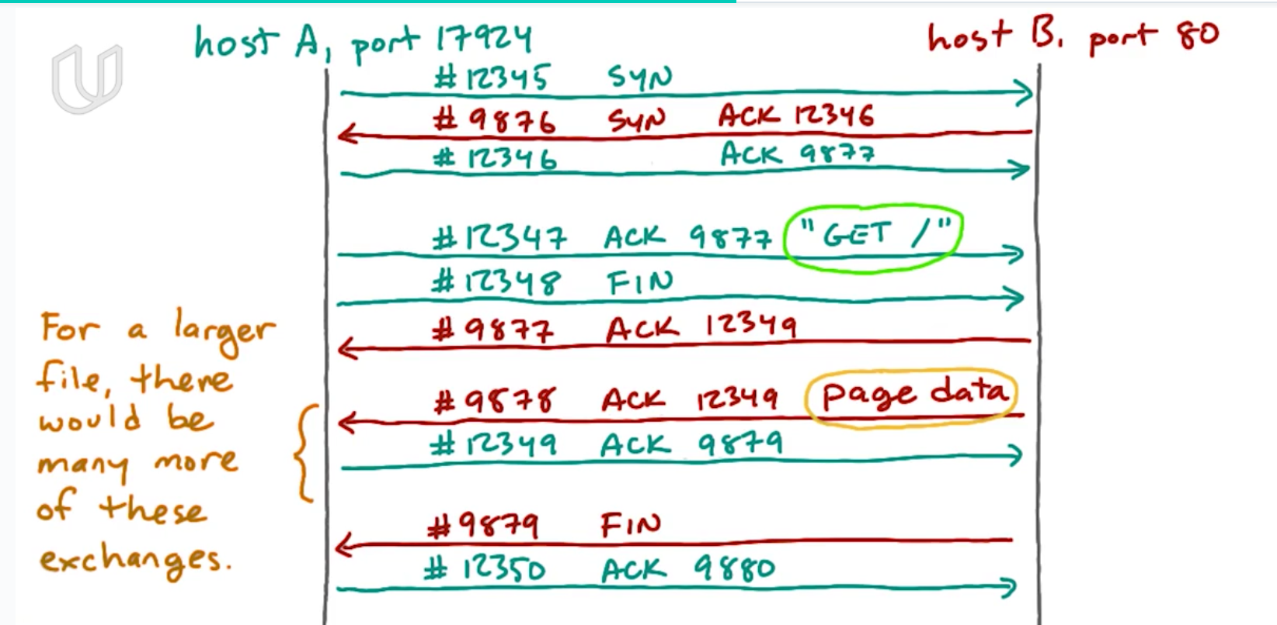

At first, the client knows the host’s ip address and port number, but the host does not know anything about the client. So client will send a packet about its ip address and port.

TCP also keeps track of the data that each endpoint is sent and make sure the other endpoint has received it. TCP will put a sequence number on each packet. Each endpoint will send an acknowledgement indicating when it’s received a particular sequence number. If any sequence number is missing, the endpoint will re-transfer that packet.

## *TCP

When an endpoint A wants to build connection between endpoint B, first A will send a packet including sequence number, A’s ip address and A’s port number(first handshake). After B receives this packet, B will send back a packet including a new sequence number and the original sequence number, indicating that B has received A’s first packet(second handshake).

Until now, A knows both A and B can send and receive packets. But B only knows he can receive packet and A can send packet. B does not know if he can send packet and A can receive packet. So A will send another packet telling B that A has received B’s message(third handshake).

After 3-way handshake, the connection between A and B is built.

## Others

The browser is responsible to translate the URL, finds the server, build connection and send request. After the server sends the required data(usually HTML document) back, the browser is responsible to show the data to client(namely read the HTML document).

HTTP is the protocal that browser use to communicate with the server

socket是在应用层和传输层之间的一个抽象层，它把TCP/IP层复杂的操作抽象为几个简单的接口供应用层调用已实现进程在网络中通信。